S Johnson
RIDGEWAY PRIMARY ACADEMY CALCULATION POLICY
2019-2020

Produced by S Johnson
Our calculation policy is based on the calculation policy produced by White Rose Maths Hub and focuses on the CPA approach to teaching maths, ensuring that children develop deep conceptual understanding, alongside procedural fluency.

The following description of the CPA Approach is taken from the Maths No Problem website.

https://mathsnoproblem.com/en/mastery/concrete-pictorial-abstract/

Concrete, Pictorial, Abstract (CPA) is a highly effective approach to teaching that develops a deep and sustainable understanding of maths in pupils. Often referred to as the concrete, representational, abstract framework, CPA was developed by American psychologist Jerome Bruner. It is an essential technique within the Singapore method of teaching maths for mastery. Although we’ve presented CPA as three distinct stages, a skilled teacher will go back and forth between each stage to reinforce concepts.

Background to the CPA framework : Children (and adults!) can find maths difficult because it is abstract. The CPA approach builds on children’s existing knowledge by introducing abstract concepts in a concrete and tangible way. It involves moving from concrete materials, to pictorial representations, to abstract symbols and problems. The CPA framework is so established in Singapore maths teaching that the Ministry of Education will not approve any teaching materials that do not use the approach.

Concrete step of CPA: Concrete is the “doing” stage. During this stage, students use concrete objects to model problems. Unlike traditional maths teaching methods where teachers demonstrate how to solve a problem, the CPA approach brings concepts to life by allowing children to experience and handle physical (concrete) objects. With the CPA framework, every abstract concept is first introduced using physical, interactive concrete materials.

Pictorial step of CPA: Pictorial is the “seeing” stage. Here, visual representations of concrete objects are used to model problems. This stage encourages children to make a mental connection between the physical object they just handled and the abstract pictures, diagrams or models that represent the objects from the problem. Building or drawing a model makes it easier for children to grasp difficult abstract concepts (for example, fractions). Simply put, it helps students visualise abstract problems and make them more accessible.

Abstract step of CPA: Abstract is the “symbolic” stage, where children use abstract symbols to model problems. Students will not progress to this stage until they have demonstrated that they have a solid understanding of the concrete and pictorial stages of the problem. The abstract stage involves the teacher introducing abstract concepts (for example, mathematical symbols). Children are introduced to the concept at a symbolic level, using only numbers, notation, and mathematical symbols (for example, +, –, x, /) to indicate addition, multiplication or division.

- Teachers should ensure that they use a range of manipulatives and representations throughout teaching of concepts, choosing the most appropriate for the concept. Manipulatives and representations may include Rekenreks, diennes, place value counters, Cuisenaire, number lines, multi-link, counters, bar models, part-whole models.
- NCETM PD materials include a wide range of representations shown on PPT slides with accompanying teacher notes https://www.ncetm.org.uk/resources/50639
- Mathsbot.com https://mathsbot.com/ includes a wide range of interactive resources.
- Further reading around manipulatives and teaching using CPA approach can be found in Visible Maths (P Matlock 2019) and Teaching for Mastery (M McCourt 2019)
The following website https://www.babcockldp.co.uk/improving-schools-settings/mathematics/teaching-resources/connective-model-and-cpa-approach discusses in detail the Connective Model (Haylock and Cockburn) and the CPA approach, as well as providing useful resources.
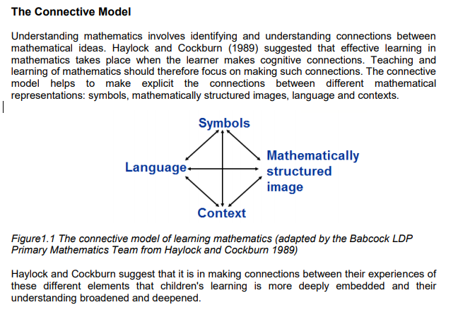
……….
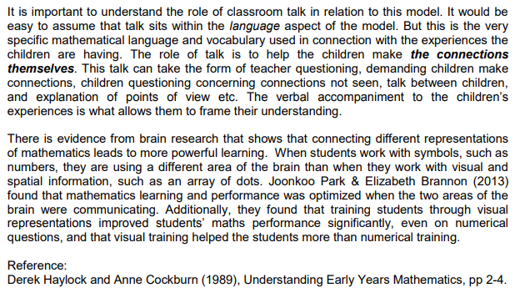
In his recent book ‘Teaching for Mastery’, Mark McCourt includes an adapted visual of Haylock and Cockburn’s ‘connective model’ writing that, ‘The Teacher will use a range of models, metaphors and examples in order to allow all pupils to see how the novel idea is connected to what they already know and how the various representations connect to each other.’ (M McCourt, Teaching for Mastery, p122)

