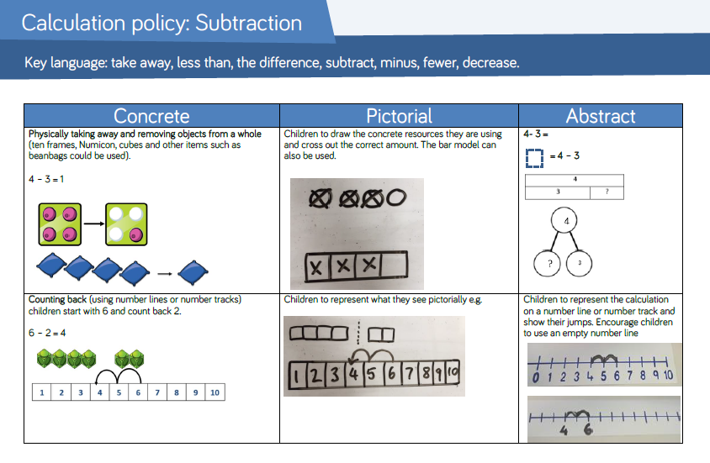

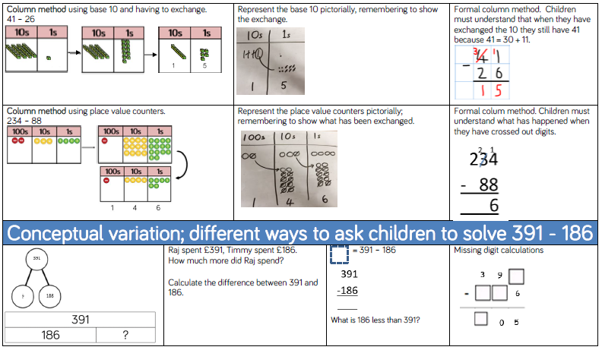
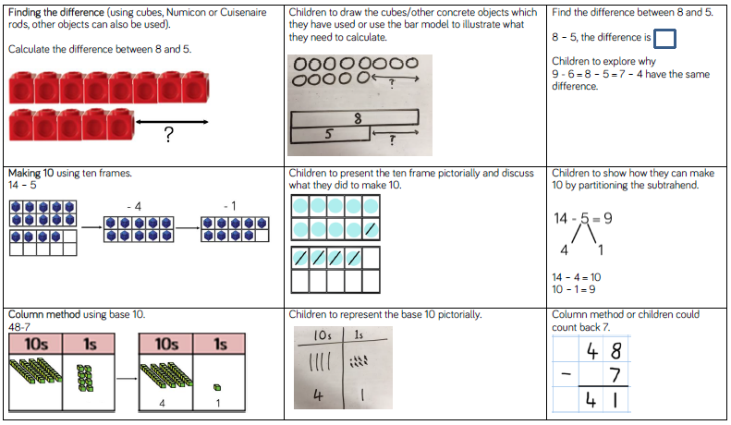
Year 1 addition and subtraction objectives:
- read, write and interpret mathematical statements involving addition (+), subtraction (–) and equals (=) signs
- represent and use number bonds and related subtraction facts within 20
- add and subtract one-digit and two-digit numbers to 20, including zero
- solve one-step problems that involve addition and subtraction, using concrete objects and pictorial representations, and missing number problems such as
7 = ? – 9

Year 3 addition and subtraction objectives:

add and subtract numbers mentally, including:
- a three-digit number and ones
- a three-digit number and tens
- a three-digit number and hundreds

- add and subtract numbers with up to three digits, using formal written methods of columnar addition and subtraction

Year 5 addition and subtraction objectives:
- add and subtract whole numbers with more than 4 digits, including using formal written methods (columnar addition and subtraction)
- add and subtract numbers mentally with increasingly large numbers
Year 4 additional and subtraction objectives:
- add and subtract numbers with up to 4 digits using the formal written methods of columnar addition and subtraction where appropriate
- estimate and use inverse operations to check answers to a calculation
Year 2 addition and subtraction objectives:

- solve problems with addition and subtraction: using concrete objects and pictorial representations, including those involving numbers, quantities and measures AND applying their increasing knowledge of mental and written methods
- recall and use addition and subtraction facts to 20 fluently, and derive and use related facts up to 100.
add and subtract numbers using concrete objects, pictorial representations, and mentally, including:
- ▪ a two-digit number and ones
- ▪ a two-digit number and tens
- ▪ two two-digit numbers
- ▪ adding three one-digit numbers

- show that addition of two numbers can be done in any order (commutative) and subtraction of one number from another cannot

