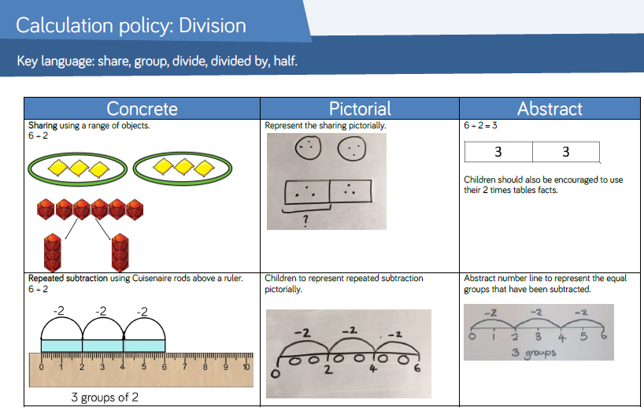

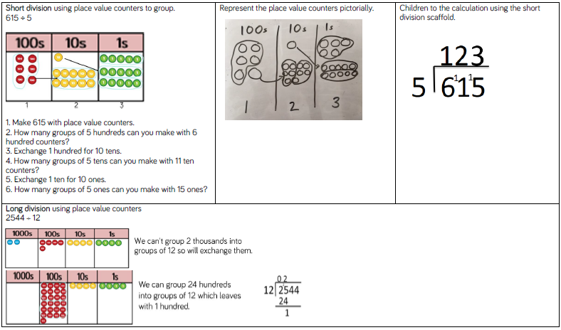
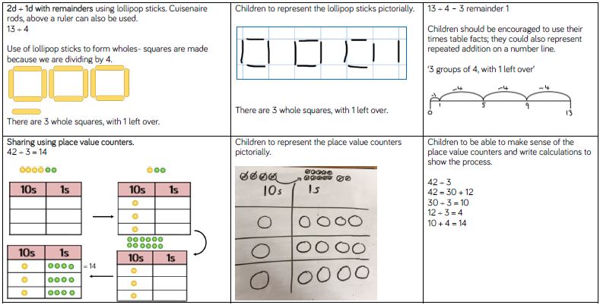
Year 4 multiplication & division objectives:
recall multiplication and division facts for multiplication tables up to 12 × 12.
use place value, known and derived facts to multiply and divide mentally, including: multiplying by 0 and 1; dividing by 1; multiplying together three numbers.
recognise and use factor pairs and commutativity in mental calculations.
multiply two-digit and three-digit numbers by a one-digit number using formal written layout.

solve problems involving multiplying and adding, including using the distributive law to multiply two digit numbers by one digit, integer scaling problems and harder correspondence problems such as n objects are connected to m objects.

Year 3 multiplication & division objectives:
recall and use multiplication and division facts for the 3, 4 and 8 multiplication tables.
write and calculate mathematical statements for x and ÷ using the multiplication tables that they know, including for two-digit numbers times one-digit numbers, using mental and progressing to formal written methods.
solve problems including missing number problems, involving x and ÷ including positive integer scaling problems and correspondence problems in which n objects are connected to m objects.
Year 2 multiplication & division objectives:
recall and use multiplication and division facts for the 2, 5 and 10 multiplication tables, including recognising odd and even numbers.
calculate mathematical statements for multiplication and division within the multiplication tables and write them using the multiplication (×), division (÷) and equals (=) signs.
show that multiplication of two numbers can be done in any order (commutative) and division of one number by another cannot.
solve problems involving multiplication and division, using materials, arrays, repeated addition, mental methods, and multiplication and division facts, including problems in contexts.
Year 1 multiplication & division objectives:
solve one-step problems involving multiplication and division, by calculating the answer using concrete objects, pictorial representations and arrays with the support of the teacher.

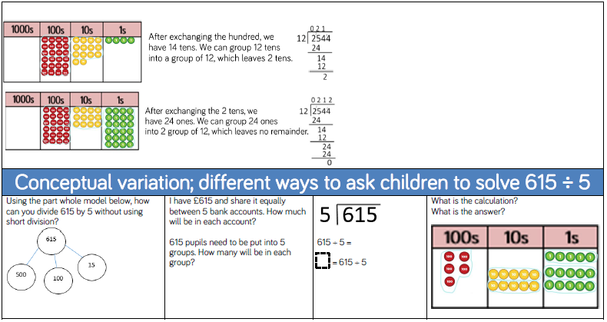

Year 6 multiplication & division objectives:
multiply multi-digit numbers up to 4 digits by a two-digit whole number using the formal written method of long multiplication.
divide numbers up to 4 digits by a two-digit whole number using the formal written method of long division, and interpret remainders as whole number remainders, fractions, or by rounding, as appropriate for the context.
divide numbers up to 4 digits by a two-digit number using the formal written method of short division where appropriate, interpreting remainders according to the context.
perform mental calculations, including with mixed operations and large numbers.
identify common factors, common multiples and prime numbers
use their knowledge of the order of operations to carry out calculations involving the four operations.
solve addition and subtraction multi-step problems in contexts, deciding which operations and methods to use and why.

Year 5 multiplication & division objectives:
multiply numbers up to 4 digits by a one- or two-digit number using a formal written method, including long multiplication for two-digit numbers.
multiply and divide numbers mentally drawing upon known facts.
divide numbers up to 4 digits by a one-digit number using the formal written method of short division and interpret remainders appropriately for the context.
multiply and divide whole numbers and those involving decimals by 10, 100 and 1000.
solve problems involving multiplication and division including using their knowledge of factors and multiples, squares and cubes
solve problems involving addition, subtraction, multiplication and division and a combination of these, including understanding the meaning of the equals sign
solve problems involving multiplication and division, including scaling by simple fractions and problems involving simple rates.



