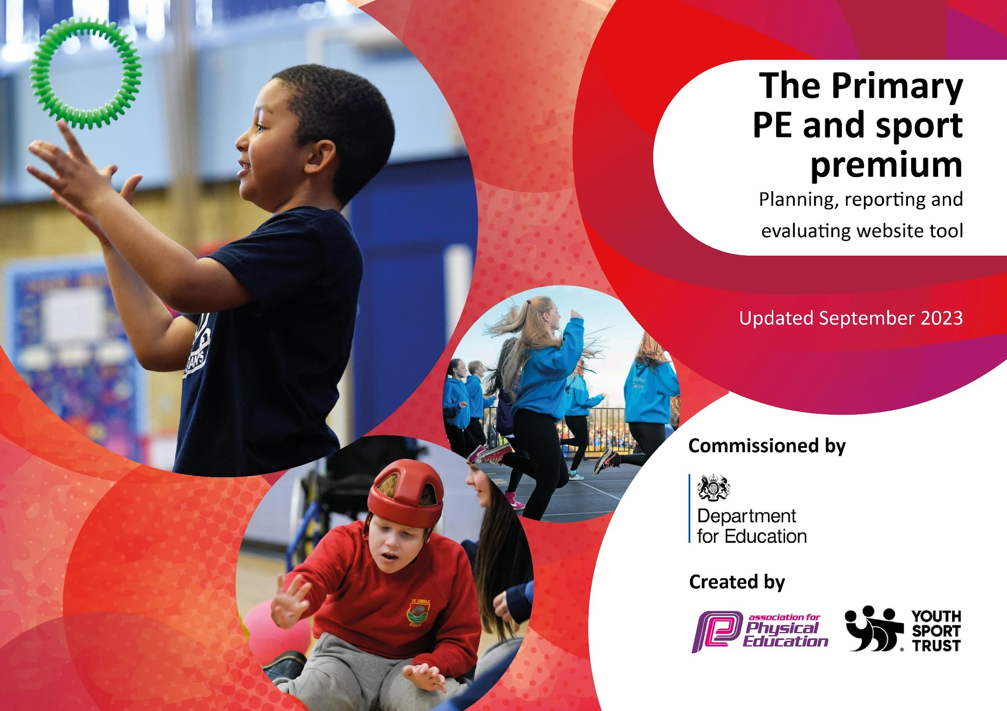

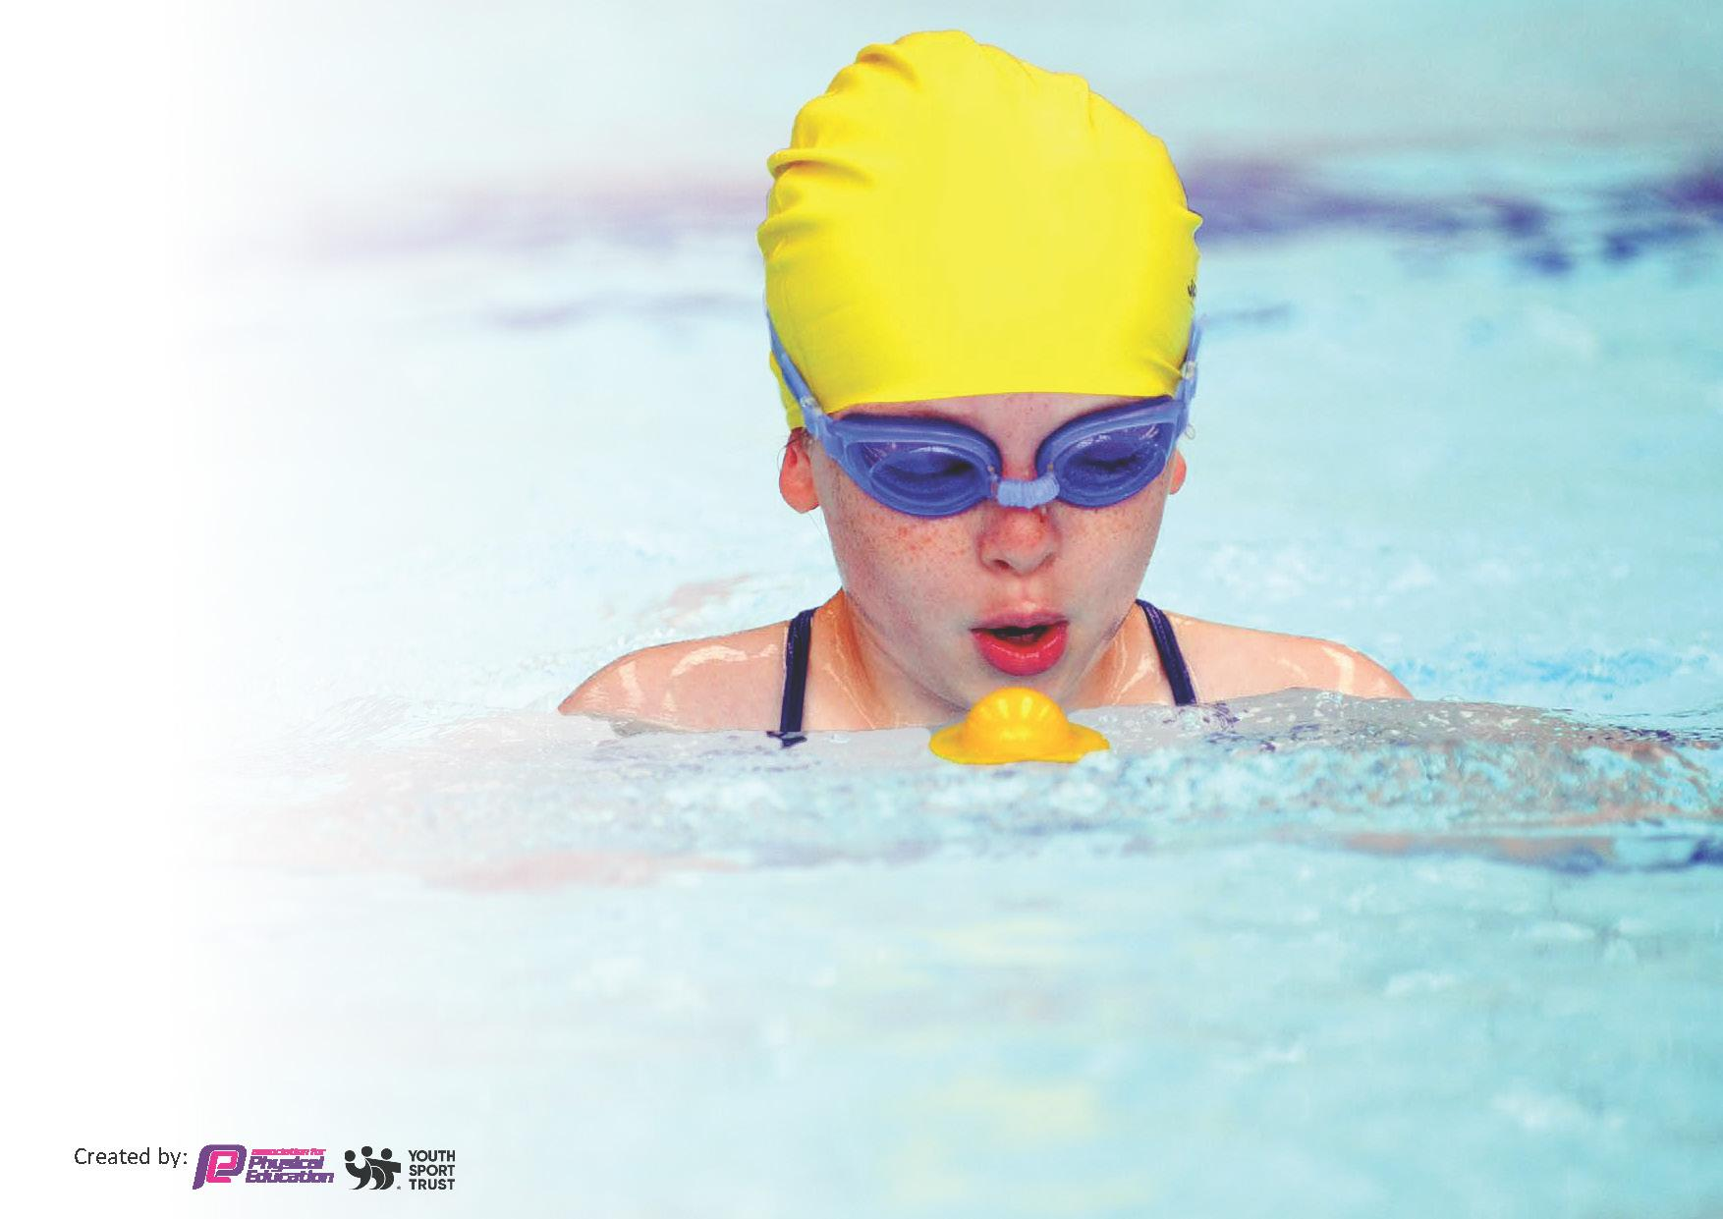
This template can be used for multiple purposes:
by:
- It enables schools to effectively plan their use of the Primary PE and sport premium
- It helps schools to meet the requirements (as set out in guidance) to publish information on their Primary PE and sport premium
- It will be an effective document to support Ofsted inspections enabling schools to evidence progress in Physical Education (PE) and evidence swimming attainment, which forms part of the PE National Curriculum. We would recommend schools consider
the Intent, Implementation and Impact of any spend, as examined within the Education Inspection Framework.

It is important that your grant is used effectively and based on school need.

Schools must use the funding to make additional and sustainable
improvements to the quality of the PE, School Sport and Physical Activity (PESSPA)
they offer. This means that you should use the Primary PE and sport premium to:

- Build capacity and capability within the school to ensure that improvements made now will benefit pupils joining the school in future years
- Develop or add to the PESSPA activities that your school already offers.

The Primary PE and sport premium should not be used to fund capital spend projects; the school’s core budget should fund these. Further detail on capital expenditure can be found in the updated Primary PE and sport premium guidance.

The Primary PE and sport premium guidance, outlines 5 key priorities that funding should be used towards. It is not necessary that spending has to meet all the key priorities, you should select the priorities that you aim to use any funding towards.

Although completing this template is not a requirement for schools, schools are required to publish details of how they spend this funding. Schools must also outline what the impact this funding has had on pupils’ PE and sport participation and attainment and how any spending will be sustainable in the future. All funding must be spent by 31st July 2024.

The Department for Education has worked closely with the Association for Physical Education (afPE) and the Youth Sport Trust (YST) to develop this template and encourages schools to use it. This template is an effective way of meeting the reporting requirements of the Primary PE and sport premium.

Review of last year’s spend and key achievements (2022/2023)

We recommend you start by reflecting on the impact of current provision and reviewing your previous spend.

Activity/Action | Impact | Comments
All children to have access to 2 hours of high quality PE per week.  Sports coach to offer activities at lunch time and after school.  Playground leader training to allow opportunity for children to be taking part in active play at lunchtimes.  Sports ambassadors play an active role in promoting physical activity.  Continue to embed and use new Rising Stars ‘Champions’ Scheme of Work.  Providing targeted activities or support to involve and encourage the least active.  Increase the involvement in school competitions.  To engage student voice and use students’ leaders to raise the profile of PE and School Sport.  The school took part in an Active Travel Month. During October 2022, students and families were encouraged to walk to school. A wallchart was given to each class to record children actively travelling to school. A trophy was given to the class that actively travelled the most.  KS1 pupils took part in a multi-skills festival designed to develop physical literacy and a range fundamental movement skills.  School took part in the FA’s Girls Football week. This included virtual football challenges for girls and a design a football competition. The ideas of the week was to raise the profile girls football and increase participation.  Curriculum PE organised to offer children access to new sports- dodgeball, boccia etc.  Before, Lunch and After school clubs offer sports to the traditional- boxercise and kick boxing.  Forest school sessions take place each week for EYFS and Y1 children | Timetables show that pupils are having correct amount of PE.  • Timetables show a variety of activities on  offer. Children regularly participated in  the clubs which ran throughout the year  • Playground leader training to develop and  embed work from last year.  • Well being and sports ambassadors trained via school and the Sports partnership.  Sports ambassadors created activities for lunchtimes for younger children to develop their physical activity  Sports coach and teachers using Scheme to provide the planning for delivery of PE Lessons  Big Moves: Improvements seen in the gross motor skills of children taking part.  PE coach and class teacher able to utilise the activities used with the rest of their class. Reception teacher using to develop the core strength of all children  Energise Club: Children enjoyed participation. Class teachers able to use activities as part of their own PE sessions.  Inclusive Sport: The school took part in an Inclusive Sport Club targeting SEND pupils. A coach from SLSSP delivered a 6 week club alongside a member of staff.  Move It March: The whole school took part in the Move It March project  School Teams have achieved success in many sports including, netball, dodgeball, cross country, hockey, football, athletics, swimming, tag rugby, table tennis and tennis  Ambassadors supported and ran activities for younger children in the school during break and lunch times.  Children’s activity levels and enjoyment of sport increased as a result of their intervention.  All classes were involved and recorded their travel modes. Award given to best class.  All KS1 children participated in a range of fun and exciting sporting/ physical activities with cross curricular links  30 girls participated in lunchtime club and football training during week.  Variety of clubs took place after school and were well attended in both KS1 and KS2  All children in EYFS and KS1 took part in forest school activities | Sports coach delivered 2 out of three pE sessions. Continue to ensure 2 hours maintained in subsequent years  Sports coach provided clubs and activities on 3 lunchtimes each week. Table tennis was most popular. Continue provision next year.  Playground leaders very successful. Children well motivated and kept activities running throughout the year.  Sports Ambassadors supported coach for lunchtime clubs and supported mini Olympics and sports days for younger children. Maintain activity.  All staff confident in using scheme to deliver PE.  Reception teacher to utilise in EYFS Curriculum for PE.  Sign up for sessions as all children enjoyed and were fully engaged. Good uptake by less active children.  Won event as most active school for the 2nd  year running.  Table tennis club which preceded competition was very successful- high uptake. Girl team won area competition  The school continues to train and give opportunities to the Sports Ambassadors. Sports Ambassadors will be trained next year to ensure student voice in represented in the school’s physical activity offer.  The school continues to promote active travel through school newsletters and social media. The school works closely with the Leicestershire County Council Officer to promote Active Travel including encouraging parents to park and stride.  Continue provision for developing a broad and balanced PE Provision  Continue to provide provision. EYFS teacher to complete Level 3 training.

Key priorities and Planning
This planning template will allow schools to accurately plan their spending.

Action – what are you planning to do | Who does this action impact? | Key indicator to meet | Impacts and how sustainability will be achieved? | Cost linked to the action
To train 4 students in year 5/ 6 to be Sports Ambassadors for the school. The ambassadors will form a School Sport Organising crew and devise an action plan to promote PE and physical activity in school.  To train 20 student Playground Leaders in Year 5/6  To train 4 Well-being Ambassadors in Year 5 /6 to promote the 5 Ways to Well-being and Internet Safety. Being Active is one of the 5 Ways to Well-being.  To participate in Active Travel Month. During October 2023, students and families will be encouraged to walk,cycle or scoot to school. A wallchart will be given to every class to record the number of children actively travelling to school. A trophy will be given to the class that actively travelled the most.  To take part in the Move It March project. Each child will be given a physical activity tracker to fill out during March 2023. Certificates and prizes will be awarded to children who achieve physical activity milestones (250 active minutes=Bronze, 500 active minutes=Silver, 750 active minutes=Gold and 1000 active minutes=Platinum). Pupils will also be given points for achieving milestones and the most active class will win a trophy.  To take part in the SLSSP Big Moves project designed for EYFS/KS1 pupils who lack fundamental movement skills. A coach from the SLSSP will deliver 6 sessions to 15 targeted pupils. The pupils undergo a fundamental movement assessment on week 1 and 6 to evaluate the impact of the intervention. A member of staff will supervise the sessions and attend a Big Moves training course.  To take part in sports competitions and events (including the less sporty/active children). We also aim to take part in sports festivals to aid transition to secondary schools.  Pupils will take part in DEVELOP festivals, which are designed to be fun and deliver sport specific skills. These events are designed for less sporty/active pupils.  These events include:  KS1 Multi-Skills, Y3/4 Mini Olympics, Y3/4 Tag Rugby, Year ¾ Girls Football, Cross Country  Pupils will take part in EXCEL competitions which are designed for our most able pupils and are based on performance.  These events include:  Basketball, Dodgeball, Tennis, Table Tennis, Tag Rugby, Football, Gymnastics, Squash, Cricket, Athletics, Swimming.  To introduce Staff Well-being Ambassadors. The ambassadors will take part in physical activity and mental health training. The ambassadors will devise an action plan to support staff well-being. The ambassador will be given funding to support their action plan.  To enter staff teams into competitions and challenges organised by SLSSP. Will plan to enter the following Staff Sports Festivals and Challenge:  (Steptober Challenges  Staff Move It March) | Pupils – the ambassadors will promote physical activity and deliver activities to younger pupils. To engage pupil voice and use students’ leaders to raise the profile of PE and School Sport.  Lunchtime Supervisors and KS1 pupils- The Playground Leaders will deliver active games to students during lunch times. The Lunchtime Supervisor will oversee the sessions and deliver active games to the KS2 pupils  Pupils- to engage pupil voice and use students’ leaders to promote a healthy and active lifestyle to their peers.  Pupils- as they will take part.  All pupils-as they will be encouraged to take part.  All staff will be encouraged to take part.  Targeted Pupils- who took part in the programme.  A member of staff- who was trained to deliver the programme in school.  Pupils- who took part in the events/competitions  Pupils- who took part in the events/competitions  Pupils- who took part in the events/competitions  Staff-the ambassadors will promote physical activity and mental well-being. The ambassadors will deliver interventions to support staff well-being.  Staff-who took part in the challenges | Key indicator 2 -Increasing engagement of all pupils in regular physical activity and sport  Key indicator 3: Raising the profile of PE and sport across the school, to support whole school improvement  Key indicator 2 -Increasing engagement of all pupils in regular physical activity and sport.  Key indicator 3: Raising the profile of PE and sport across the school, to support whole school improvement  Key indicator 3: Raising the profile of PE and sport across the school, to support whole school improvement  Key indicator 2 -Increasing engagement of all pupils in regular physical activity and sport.  Key indicator 2 -Increasing engagement of all pupils in regular physical activity and sport.  Key indicator 3: Raising the profile of PE and sport across the school, to support whole school improvement.  Key indicator 1: Increased confidence, knowledge and skills of all staff in teaching PE and sport  Key indicator 2 -Increasing engagement of all pupils in regular physical activity and sport.  Key Indicator 4- Offer a broader and more equal experience of a range of sports and activities offered to all pupils  Key Indicator 4- Offer a broader and more equal experience of a range of sports and activities offered to all pupils  Key Indicator 5- Increased participation in competitive sport  Key Indicator 4- Offer a broader and more equal experience of a range of sports and activities offered to all pupils  Key indicator 3: Raising the profile of PE and sport across the school, to support whole school improvement  Key Indicator 1: Increased confidence, knowledge, and skills of all staff in teaching PE and sport.  Key indicator 3: Raising the profile of PE and sport across the school, to support whole school improvement  Key indicator 3: Raising the profile of PE and sport across the school, to support whole school improvement | The ambassadors took control of a PE and school sport particularly at lunchtimes, and supported the physical activity of younger children in the school  Sporting achievements were also celebrated in assemblies. The school newsletter contains information about physical activity, sports clubs and fixtures.  The school continues to train and give opportunities to the Sports Ambassadors. A new cohort of Sports Ambassadors will be trained next year to ensure student voice is represented in the school’s physical activity offer.  More pupils meeting the physical activity guidelines. Children are more active at lunch times. KS1 and LKS2 children regularly attend the lunch time club the Playground Leaders run.  to training Playground Leaders next year.  The ambassadors have delivered lots of initiatives to promote active and healthy lifestyles in school. They have created worry boxes in each class; students can write down their worries and drop it in the box. The teachers will monitor the boxes and address the children’s concerns.  They ran lots of activities during Children’s Mental Health Week which included a mindfulness activities. They have continuously promoted physical activity as a way to support mental well-being.  The school is committed to engaging pupil voice and will train Well-being Ambassadors next year.  The school continues to promote active travel through school newsletters and social media. The school works closely with the SLSSP and the Leicestershire County Council Officer to promote Active Travel, including encouraging parents to park and stride.  We continue to promote physical activity outside of school through the SLSSP holiday resources, which were sent to all parents and students. The SLSSP produced resources to inspire children to be active and healthy over the Christmas, Easter and Summer holidays.  The school will continue to promote physical activity through active lesson breaks, active lunch time and PE.  A member of staff attended the Big Moves training course. The member of staff delivers regular Big Moves sessions to targeted groups of EYFS pupils.  Ridgeway took part in the following Develop Activities: Multi- sport (KS1), Mini-Olymics (LKS2), Tennis, Quick Sticks (Hockey), Dodgeball, New Age KurlingFootball, and Tag Rugby.  Ridgeway competed in the following Excel activities:  Indoor Athletics, Area Athletics, Dodgeball, Football, Swimming, Basketball, Netball, Table Tennis, Dance and Cross Country.  In total- All 70 of our KS1 children and 85 (M-48 F-37) children in KS2 took part in either Develop or Excel activities  All of the children who took part fully enjoyed the experience of competing against children from other schools. The children who took part were more likely to volunteer for additional sporting activity, and to continue sport outside of school.  The school will continue to take part in competitions next academic year. The SLSSP will develop a calendar of competitions/festivals designed to INSPIRE pupils, DEVELOP physical/sports skill and enable students to EXCEL. The school is committed to taking part in the local competitions.  Each year group participated in the LSLSSP Virtual Competitions during the school year.  The school will continue to take part in competitions next academic year.The SLSSP will promote a blended approach next year, both virtual and face to face competitions will take place.  Staff Ambassador role to be further developed next year as the school is committed to promoting staff well-being and physical activity.  Staff took part in two sporting events. The staff won the area Move it March students challenge. Students and staff encouraged each other to step more and be involved in activity. The staff completed  The school is committed to promoting staff well-being and physical activity and will aim to promote and encourage staff involvement next year. | South Leicestershire School Sports Partnership (SLSSP) Membership Costs £2,700  SLSSP Membership Costs (see amount above)  SLSSP Membership Costs (see amount above)  SLSSP Membership Costs (see amount above)  SLSSP Membership Costs (see amount above)  SLSSP Membership Costs (see amount above)  SLSSP Membership Costs (see amount above)  SLSSP Membership Costs (see amount above)  SLSSP Membership Costs (see amount above)  SLSSP Membership Costs (see amount above)

Our PE co-ordinator will take part in local PE Subject Leader meetings. The PE Co-ordinator shared the lessons with all colleagues during staff meetings  Our PE co-ordinator will attend the South Leicestershire PE Conference, taking part in a variety of workshops.  To take part in the Learn To Cycle CPD. The aim of the CPD is to train a member of staff to lead balance bike sessions.  To participate in the Energise Club The 10 weeks of sessions will be delivered by SLSSP staff. The club will target inactive/less confident Year 3 and 4 pupils. The sessions will include fun physical games and mindfulness. A member of staff will supervise the sessions.  To take part in the FA’s Girls Football week. This includes virtual football challenges for girls and a football design competition. The idea of the week was to raise the profile girls football and increase participation.  All children to have access to 2 hours of high quality PE per week.  Sports coach to offer activities at lunch time and after school.  All children in EYFS and KS1 to access high quality forest school sessions  . | PE Co-ordinator- to attend the termly meetings  PE Co-ordinator- to attend the termly meetings  Member of staff-trained to deliver the sessions.  Targeted pupils-who took part in the sessions.  Pupils-who take part in the activities  All Children who take part in PE sessions  All children in EYFS and KS1 | Key Indicator 1: Increased confidence, knowledge, and skills of all staff in teaching PE and sport.  Key Indicator 1: Increased confidence, knowledge, and skills of all staff in teaching PE and sport.  Key Indicator 1: Increased confidence, knowledge, and skills of all staff in teaching PE and sport.  Key indicator 2 -Increasing engagement of all pupils in regular physical activity and sport.  Key Indicator 4- Offer a broader and more equal experience of a range of sports and activities offered to all pupils  Key indicator 2 -Increasing engagement of all pupils in regular physical activity and sport.  Key Indicator 4- Offer a broader and more equal experience of a range of sports and activities offered to all pupils  Key indicator 3: Raising the profile of PE and sport across the school, to support whole school improvement  Key indicator 2 -Increasing engagement of all pupils in regular physical activity and sport.  Key Indicator 4- Offer a broader and more equal experience of a range of sports and activities offered to all pupils  Key Indicator 4- Offer a broader and more equal experience of a range of sports and activities offered to all pupils | The PE Co-ordinator shared the learning points with all staff.  Training opportunities from LSLSSP shared with staff.  School to continue being an active member in meetings.  PE Co-Ordinator was unable to attend this year, but plans to attend the conference next year.  SLT will continue to champion the PE co-ordinator role. The PE co-ordinator will deliver whole school staff workshops. The PE Co-ordinator will also survey staff to highlight areas of PE where further CPD is needed.  Staff in EYFS have utilized training, and use regular with pupils in school  Club was popular and well attended. Children thoroughly enjoyed the physical activity and the range of activities offered.  Children enjoyed Girl football sessions. The number of girls taking part in football has increased with Year 3 and 4 children playing the sport outside of school and joining school team.  The school will continue to promote female participation in physical activity.  Children were provided with high quality PE lessons provided by school’s PE Coach.  Range of sports clubs provided for all ages.  School is committed to ensure that high quality PE provision and clubs continue  Children and staff felt the children thrived and enjoyed the high quality forest school provision by the Forest School practitioner.  School is committed to ensuring that high quality Forest school provision continues in the Early Years and KS1 | SLSSP Membership Costs (see amount above)  SLSSP Membership Costs (see amount above)  SLSSP Membership Costs (see amount above)  SLSSP Membership Costs (see amount above)  £15 360 contributed towards coach salary  £320 contributed towards the cost of Forest School practitioner

Key achievements 2023-2024
This template will be completed at the end of the academic year and will showcase the key achievements schools have made with their Primary PE and sport premium spending.

Activity/Action | Impact | Comments
All children continue to have access to 2 hours of high quality PE per week.  Sports coach to offer activities at lunch time and after school.  Playground leader training to allow opportunity for children to be taking part in active play at lunchtimes.  Sports ambassadors play an active role in promoting physical activity.  Continue to embed and use new Rising Stars ‘Champions’ Scheme of Work.  Providing targeted activities or support to involve and encourage the least active.  Increase the involvement in school competitions.  To engage student voice and use students’ leaders to raise the profile of PE and School Sport.  The school took part in an Active Travel Month. During October 2023, students and families were encouraged to walk to school. A wallchart was given to each class to record children actively travelling to school. A trophy was given to the class that actively travelled the most.  KS1 pupils took part in a multi-skills festival designed to develop physical literacy and a range fundamental movement skills.  School took part in the FA’s Girls Football week again to continue to raise the profile girls football and increase participation.  Sports coach provided a range of sports clubs for all age ranges.  Forest school sessions take place each week for EYFS and Y1 children | Timetables show that pupils are having correct amount of PE.  • Timetables show a variety of activities on  offer. Children regularly participated in  the clubs which ran throughout the year  • 20 Playground leaders were trained and lead a series of activities.  • Well being and sports ambassadors trained via school and the Sports partnership.  Sports ambassadors created activities for lunchtimes for younger children to develop their physical activity  Sports coach and teachers using Scheme to provide the planning for delivery of PE Lessons  Big Moves: Improvements seen in the gross motor skills of children taking part.  PE coach and class teacher able to utilise the activities used with the rest of their class. Reception teacher using to develop the core strength of all children  Energise Club: Children enjoyed participation. Class teachers able to use activities as part of their own PE sessions.  Inclusive Sport: The school took part in an Inclusive Sport Club targeting SEND pupils. A coach from SLSSP delivered a 6 week club alongside a member of staff.  Move It March: The whole school took part in the Move It March project  School Teams have achieved success in many sports including, netball, dodgeball, cross country, hockey, football, athletics, swimming, tag rugby, table tennis and tennis  Ambassadors supported and ran activities for younger children in the school during break and lunch times.  Children’s activity levels and enjoyment of sport increased as a result of their intervention.  All classes were involved and recorded their travel modes. Award given to best class.  All KS1 children participated in a range of fun and exciting sporting/ physical activities with cross curricular links  30 girls participated in lunchtime football activities during week.  Variety of clubs took place after school and were well attended in both KS1 and KS2  All children in EYFS and KS1 took part in forest school activities | Sports coach delivered 2 out of three pE sessions. Continue to ensure 2 hours maintained in subsequent years  Sports coach provided clubs and activities on 3 lunchtimes each week. Table tennis and girls football were popular. Provision at lunchtime to be continued and improved if possible  Playground leaders very successful. Children well motivated and kept activities running throughout the year.  Sports Ambassadors supported coach for lunchtime clubs and supported mini Olympics and sports days for younger children. Maintain activity.  All staff confident in using scheme to deliver PE.  Staff to be surveyed and to be provided with training if required next academic year.  Staff found these sessions essential and wish to engage with them again next yer.  Sign up again for sessions as all children enjoyed and were fully engaged. Good uptake by less active children.  Won event as most active school for the 3rd  year running. (Now outright winners!!)  Table tennis club which preceded competition was very successful- high uptake. Girl team won area competition for the second year running  The school continues to train and give opportunities to the Sports Ambassadors. Sports Ambassadors will be trained next year to ensure student voice in represented in the school’s physical activity offer.  The school continues to promote active travel through school newsletters and social media. The school works closely with the Leicestershire County Council Officer to promote Active Travel including encouraging parents to park and stride.  Continue provision for developing a broad and balanced PE Provision  Continue to promote girls participation in sport.  Ensure sporting clubs continue at lunchtimes and after school  EYFS teacher has completed Outdoor education training

Swimming Data
Meeting National Curriculum requirements for swimming and water safety.
Priority should always be given to ensuring that pupils can perform safe self-rescue even if they do not fully meet the first two requirements of the National Curriculum programme of study

Question | Stats: | Further context  Relative to local challenges
What percentage of your current Year 6 cohort can swim competently, confidently and proficiently over a distance of at least 25 metres? | 95.2% | There are 42 children in cohort.  Children swim at school for one term in year 4.  This short period of time is due to the prohibitive costs of transport to the swimming pool and voluntary contributions falling short by approx. £1000.
What percentage of your current Year 6 cohort can use a range of strokes effectively [for example, front crawl, backstroke, and breaststroke]? | 57% | Although their only 2 non-swimmers in the year group, just over half of the group are competent swimmers over a longer distance more than 25m using a range of strokes

What percentage of your current Year 6 cohort are able to perform safe self-rescue in different water-based situations? | 57%
If your schools swimming data is below national expectation, you can choose to use the Primary PE and sport premium to provide additional top-up sessions for those pupils that did not meet National Curriculum  requirements after the completion of core lessons. Have you done this? | No
Have you provided CPD to improve the knowledge and confidence of staff to be able to teach swimming and water safety? | Yes | Staff who support swimming renew there training on a regular cycle

Signed off by:

Executive Head Teacher: | Sarah Bishop
Subject Leader or the individual responsible for the Primary PE and sport premium: | Dave Turner
Governor: | Richard Moor
Date: | 31st July 2024

