

SEND VISION
September 2024



Intent: We are Inclusive!
Learn – AT believes in the power of education and learning to transform children’s life chances and choices. Every child flourishes and enjoys learning with access to a rich, rounded, rigorous and coherent curriculum. Each school has its own variation of this vision:
At Ridgeway Primary Academy, our vision is to create responsible citizens who make a positive contribution to society, confident, articulate individuals who can lead safe, healthy and fulfilling lives, successful, engaged learners who are knowledgeable, skilled, make progress and achieve.
At Great Bowden Academy, our vision is for each member of our school family to experience life in all its fullness both now and in the future. We are an inclusive welcoming community valuing everyone for who they are and enabling all to flourish.
To support this, we carefully plan our learning to ensure all our pupils can access the curriculum.
High Quality Teaching addresses the needs of all learners as it focuses on inclusive practise. This reduces the barriers to learning and participation in the classroom and promotes a high standard for all pupils in order for them to reach their potential. Good teaching for SEND pupils is good teaching for all.
Adaptive teaching quote…… OFSTED framework…. Slide from training

We foster an inclusive mindset and High Quality Teaching and learning is underpinned by the following key messages:
- Create a positive and supportive environment for all pupils, without exception.
- Build an ongoing, holistic understanding of your pupils and their needs.
- Ensure all pupils have access to high quality teaching.
- Complement high quality teaching with carefully selected small group and one to one interventions.
- Work effectively with teaching assistants.
(messages developed by Education Endowment Foundation)

Implementation: Our Graduated Approach and key influences.
We have developed the graduated approach in meeting the needs of SEND pupils. Our identification of needs and inclusive practice continues to evolve. This journey has been supported by the work of the EEF and our engagement with the Trust. We consider ourselves learners and are constantly discovering ways in which we can develop our inclusive pedagogy and to become the best teachers that we can be.
This SEND Vision, and subsequently our high quality teaching and learning, has been, and continues to be, influenced and developed using information from a range of sources, including the following:
- Support from the Learn AT Strategic SEND Team, including Libby Harris as Lead Professional for SEND and Natalie Packer as trustee and SEND Consultant.
- Dyslexia Strategic Plan
- Ridgeway / Great Bowden SEND Report
- Ridgeway / Great Bowden SEND policy & SEND flowchart
- AET Schools Competency Framework
https://www.autismeducationtrust.org.uk/resources/aet-schools-competency-framework
- Local offer
https://www.leicestershire.gov.uk/education-and-children/special-educational-needs-and-disability
- SEND Code of Practice
SEND_Code_of_Practice_January_2015.pdf (publishing.service.gov.uk)
- Special Educational Needs in Mainstream Schools: A Guidance Report
Special Educational Needs in Mainstream Schools | EEF (educationendowmentfoundation.org.uk)
- Teacher Handbook: SEND
https://www.sendgateway.org.uk/resources/teacher-handbook-send

- https://www.thesendcast.com

- The Inclusive Classroom by Daniel Sobel & Sara Alston (2021)
- The Research ED Guide to Special Educational Needs, edited by Karen Wespieser (2021)
- Inclusion – A Principled Guide for School Leaders by Nicola Crossley and Des Hewitt
- US SEND Project – Trust wide CPD 24-25

- Masters in Learning and Teaching (SpLD – Dyslexia) completed by Libby Harris (2014)
- National Award for SENCos completed by Libby Harris (2021) & at GBA, R Blagburn (2017)

This is by no means an exhaustive list and new research is released regularly through Twitter/ blogs/ websites.

What can be seen in our Inclusive Lessons?
At Ridgeway Primary Academy & Great Bowden Academy, we have worked together to create an Adaptive Teaching Toolkit. This is a range of approaches and strategies that staff can implement to provide pupil with additional support they need to access learning and feel success. This will include a variety of adaptations at different phases in the lesson:

- Phase 1 – Transition, entering the classroom and preparing to learn.
- Phase 2 – Delivering and receiving instructions and whole class engagement
- Phase 3 – Individuals working as a class
- Phase 4 – Individuals fitting into a group of learners
- Phase 5 – the last 5 minutes

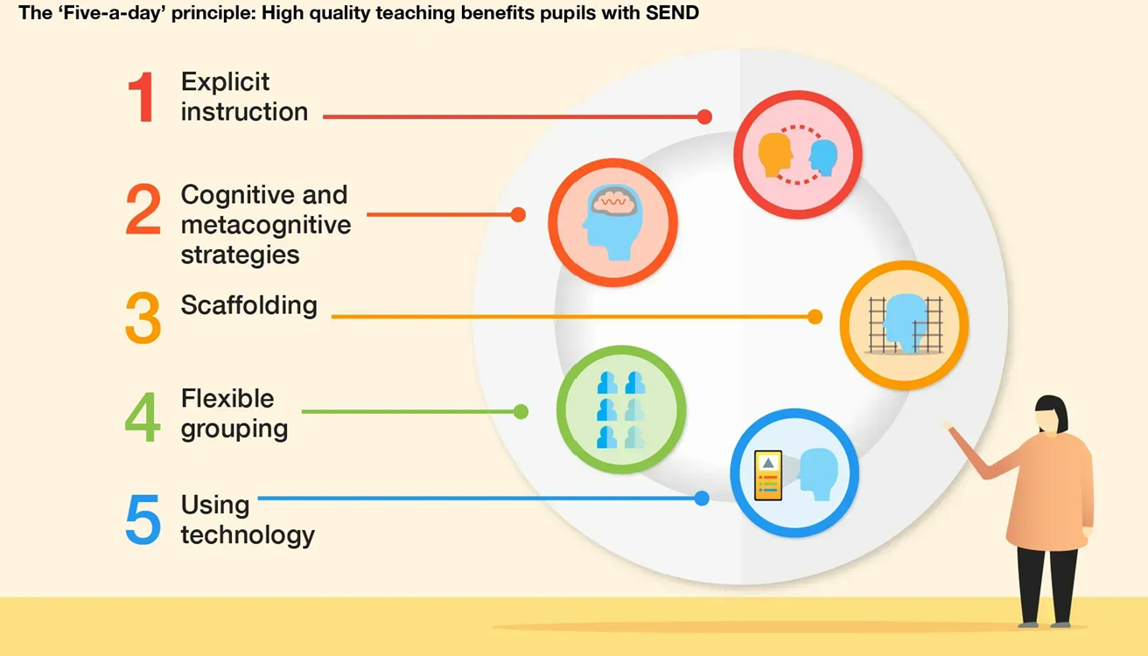

Teachers will use these 5 principles throughout their Quality First Teaching. More guidance surrounding these will be found in: Special Educational Needs in Mainstream Schools (educationendowmentfoundation.org.uk)

Other features of an inclusive classroom would be:
- A visual timetable
- Manipulatives
- Wordbanks
- Visuals
- Task plan / checklist
- Pastel shade IWB
- Range of books on display (for example dyslexia friendly and inclusive)
- Sensory breaks provided when required
- Equal opportunities and experience a broad and balanced curriculum
- Develop metacognition

Interventions will be carefully planned and timetabled as they should not replace QFT.
Teachers will also embrace, celebrate and promote differences through the environment,
resources and an inclusive attitude. Children will be encouraged to reach their full potential.

Intervention examples:
- Pre-teaching
- Precision teaching
- Sounds – Write phonics (additional)
- Social communication groups
- Wellbeing
- Touch typing
- Vocabulary building
- Speech and Language therapy

What is our SEND Process?

If there are concerns about a child
The class teacher and parents will have a meeting to discuss this the concerns and what could be done. Key questions on the monitoring form about learning and behaviour should be asked alongside looking at the support strategies in place. A quick check of need can be completed.
A monitoring form (Quick checker) can be completed.
The class teacher can complete this outlining both parent and teacher concerns discussed in the original meeting. This will be shared with the SENDCo and advice will be given about adjustments made. The class teacher will monitor the impact of any reasonable adjustments made in the classroom or interventions that are put into place over a 6-week period. Occasionally advice from another professional may replace this stage.

An Initial Concerns form (Babcock) must be completed.
If there are still concerns after this, an initial concerns form will need to be completed. Parental and pupil voice will be included in this and this can be the basis of an in-depth conversation with the SENDCo. The child may be monitored over a 12 week period (first 6 weeks have been monitored in previous stage) with the impact of provisions being evaluated.
SEND / Inclusion register
After the period of monitoring, the child may be added to the SEND register or the Inclusion register.

If they are on the SEND register, a termly learning plan will be implemented. This will contain a summary of strengths and concerns as well as up to 4 individualised targets. Each target will have a success criteria and strategies on how to meet these. They will be reviewed and a new one created in November, March and June. The class teacher will meet with the parents and child to complete these. Parental and pupil voice will be included. These will be monitored by the SENDCo and assessments may be carried out. The SENDCo may liaise with external agencies on how best to meet the child’s need if required. External agencies may include Autism Outreach, Specialist Teaching Service, Educational Psychologists, Speech and Language Therapists etc. If parents would like to speak directly to the SENDCo, contact the school office.

The Inclusion Register is for those children who need ongoing reasonable adjustments made to classroom practise to ensure that they are able to access the learning, without the requirement of targeted interventions. This would be documented through a 1-page profile. Some children may require some extra support for a time limited period. This can be through other kinds of plans (SALT, behaviour, bereavement etc).
1 Page Profile
If SEND children require specific strategies to be implemented in the classroom through whole class teaching, these will be identified on a 1 page profile. The child will be involved in creating this and discussing what works for them.

Additional Funding
Sometimes some children need more support, so if this is the case the SENDCo would apply for SEND Intervention Funding or an EHCP. This would be in collaboration with evidence provided from home and the class teacher. External professionals would also provide their advice.

SEND Intervention Funding
This is given by the LA for a set period of time for specific provisions to be put into place. This
can be applied to be extended if required.

EHCP
If a need is longer lasting then an EHCP maybe applied for. If this is awarded by the LA, it can be in place up to the age of 25 years but is reviewed on an annual basis. The parents, child, SENDCo, class teacher and any other involved professionals will be invited to attend the review.
The EHCP will recommend certain provision and support to meet the needs of the child. If a
child still needs more specialist support, then this is required for them to access a specialist
setting.

Working with parents:

Termly meetings for parents of children with learning plans
All parents are invited to 2 parents’ evenings a year, for SEND pupils this will include an additional meeting in the 3rd term. The learning plans will be reviewed and updated with the class teacher, with parents’ input. The child’s voice will also be gained.

Learning plan deadlines
November
March
June

Coffee mornings
The coffee mornings alternate venues but parents from both schools are invited to attend. We invite a range of outside speakers to meet the parents and present on relevant topics. There is also an opportunity to chat to other parents and staff.

October at Ridgeway
February at Great Bowden
June at Ridgeway

