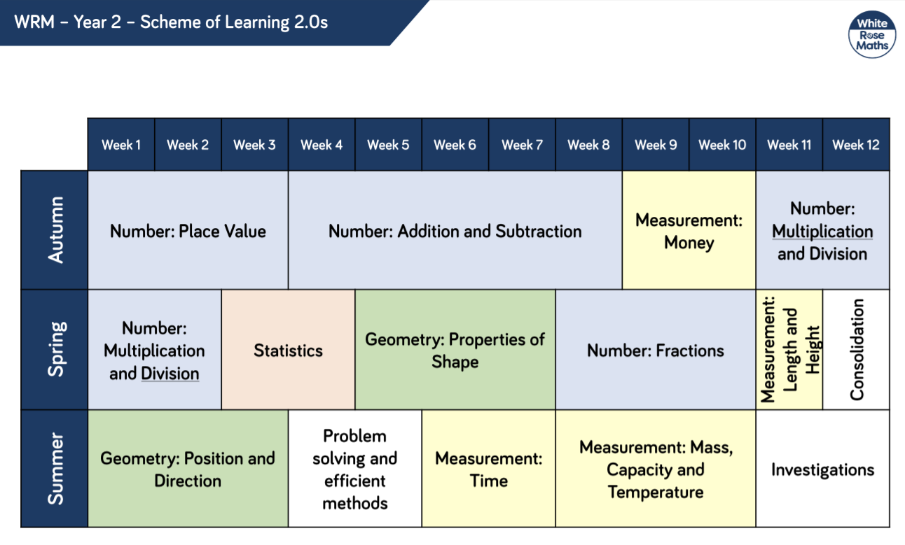
The White Rose Maths Scheme of Learning provides an overview of progression in maths learning across the year. We use WRM, alongside other quality schemes, to inform our maths planning.
Through following a Teaching for Mastery approach and using responsive teaching and ongoing AfL, class teachers make a judgement as to the length of time spent on a unit of learning. Our aim is for the vast majority of pupils to master the objectives for their year group and we believe class teachers are best placed to make decisions using WRM as a guide whilst ensuring full coverage of the maths curriculum.

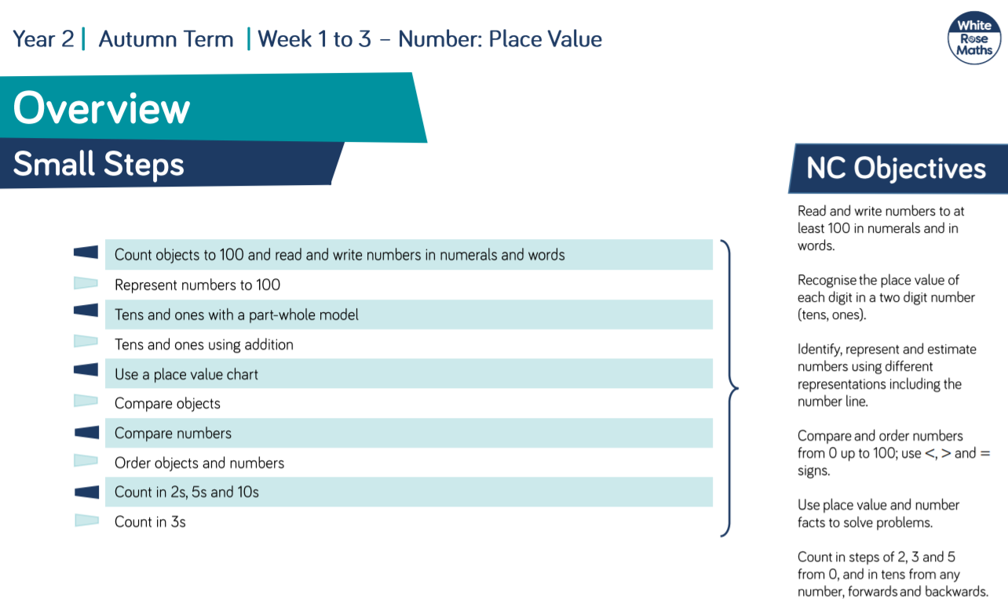

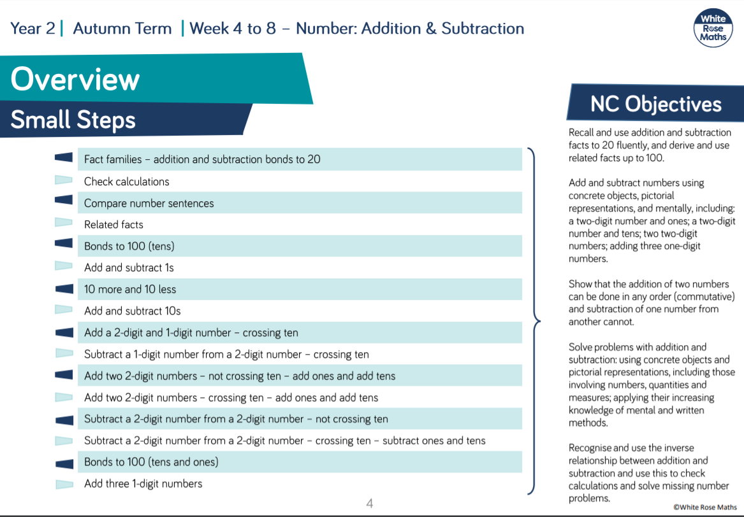
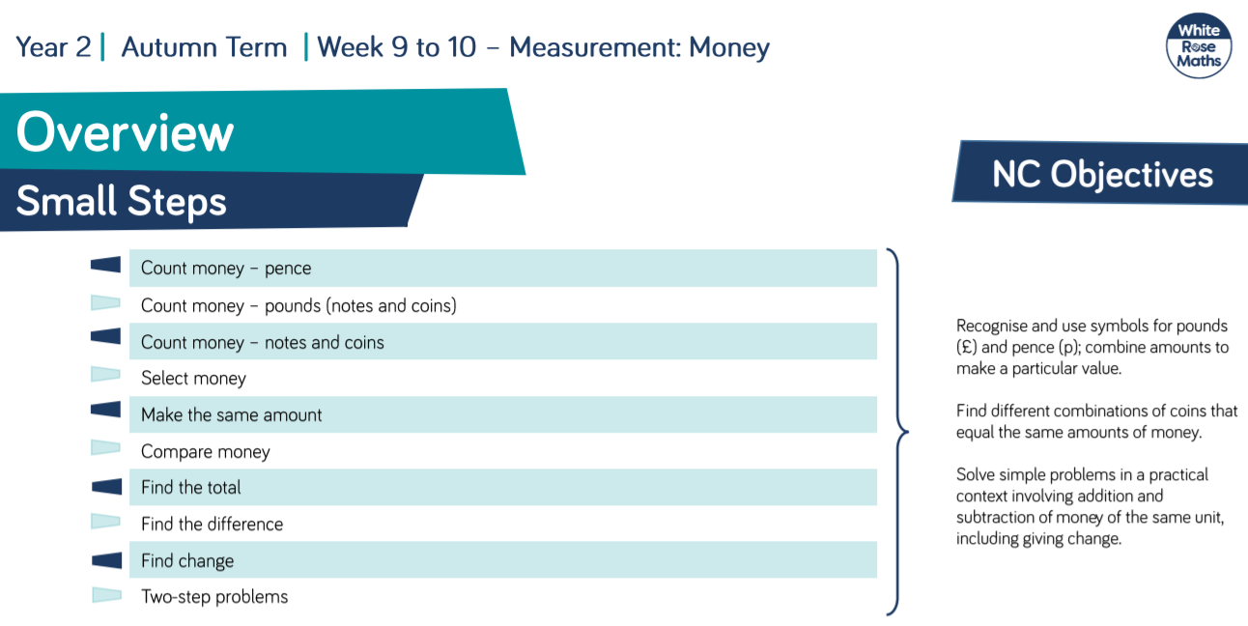
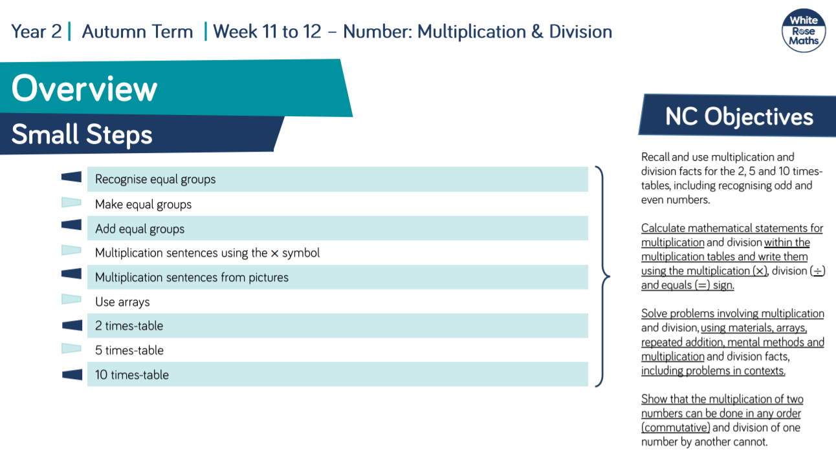

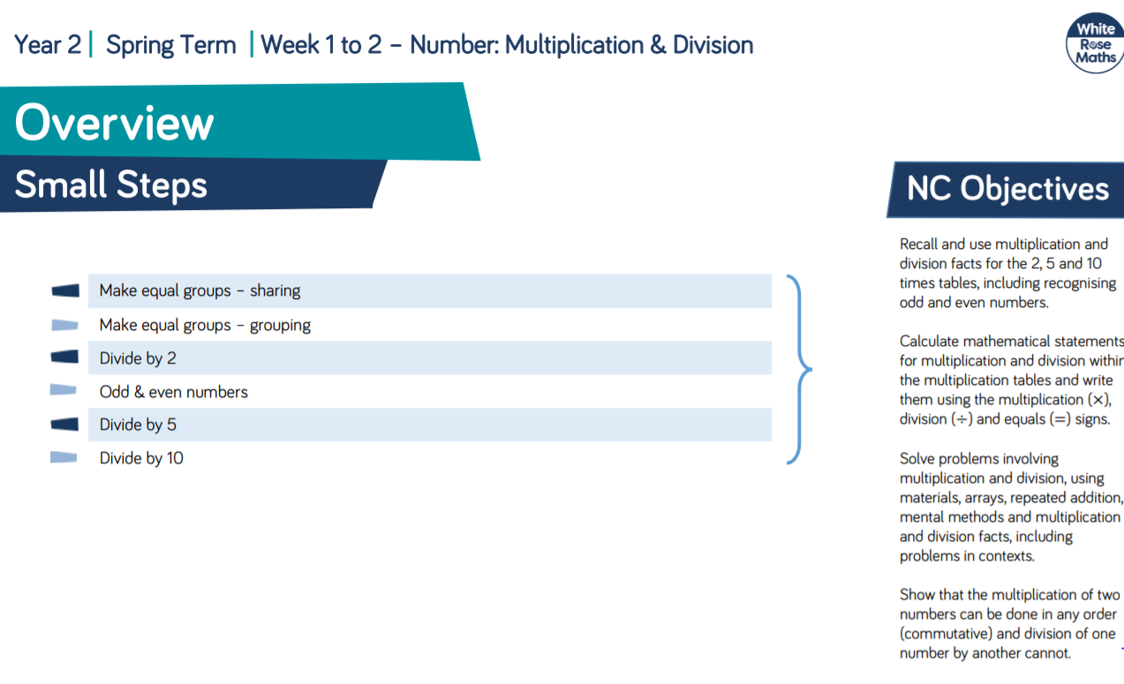
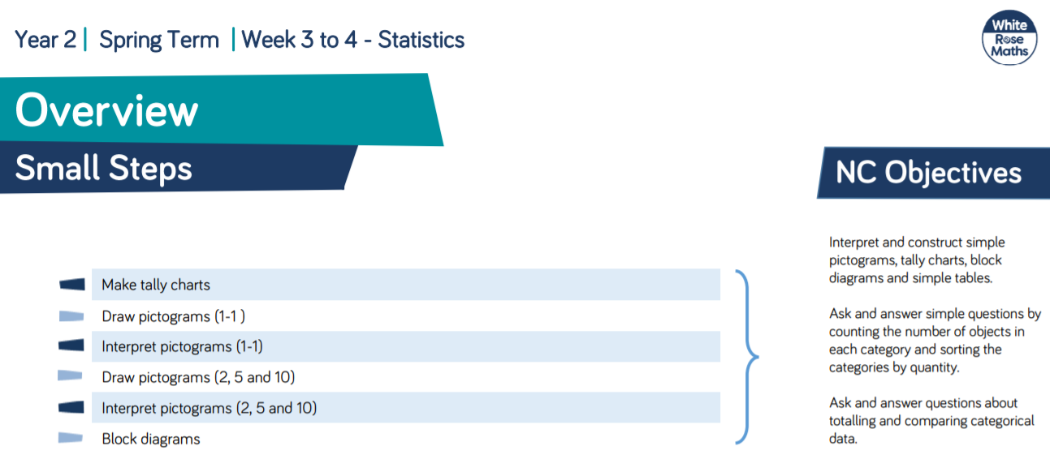
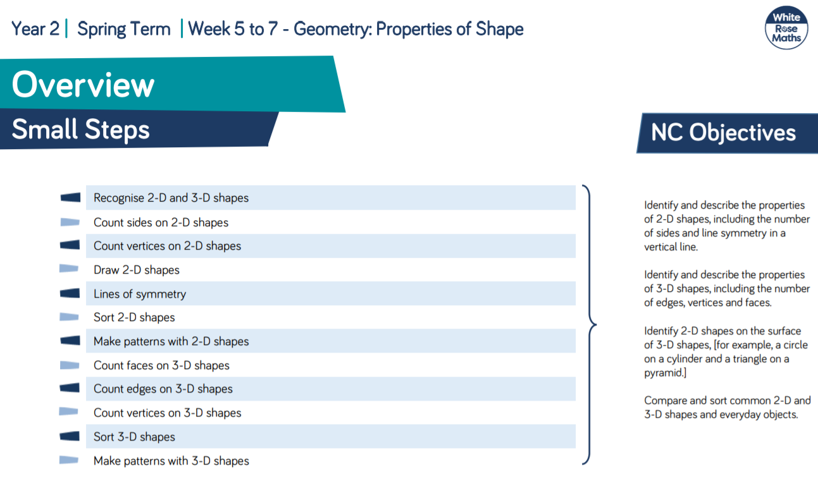
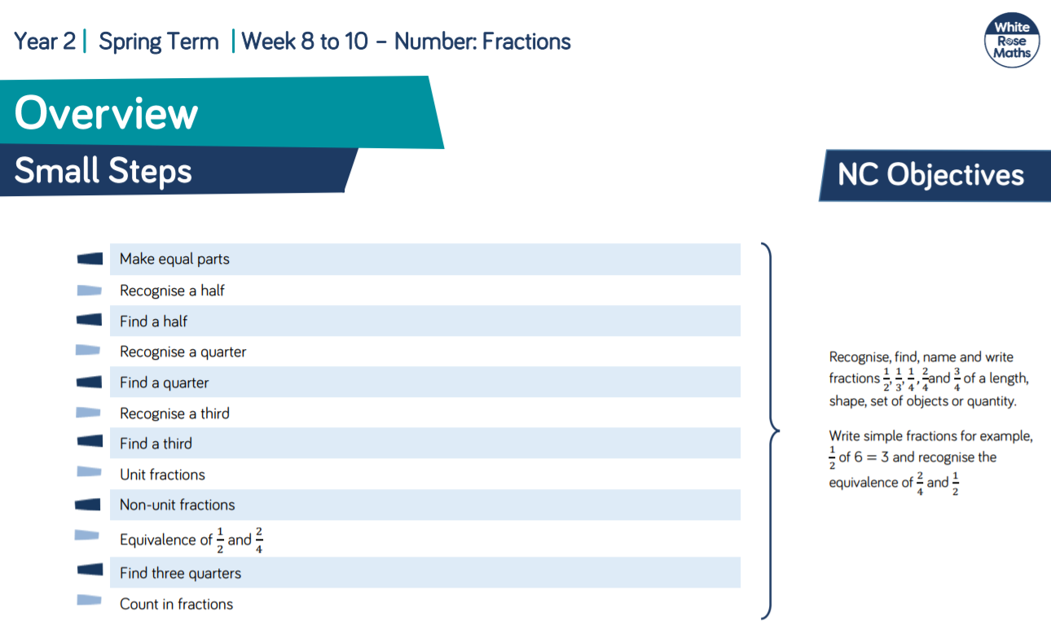

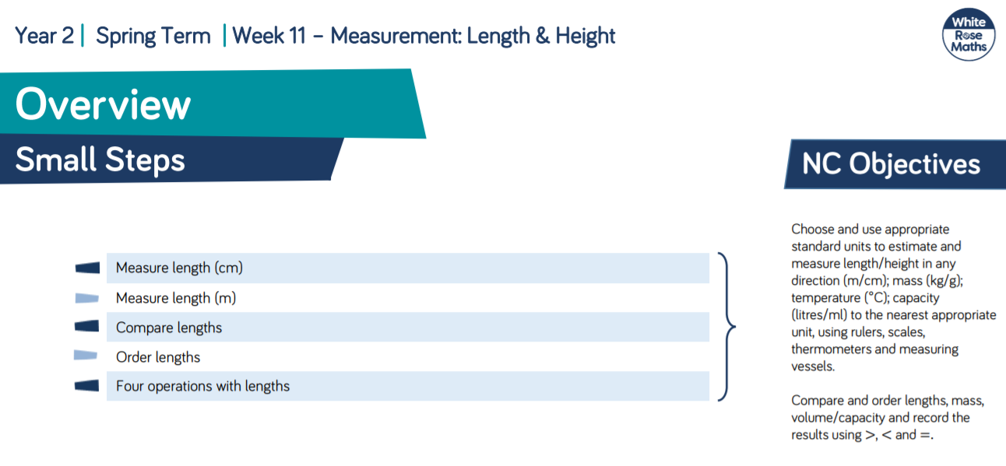

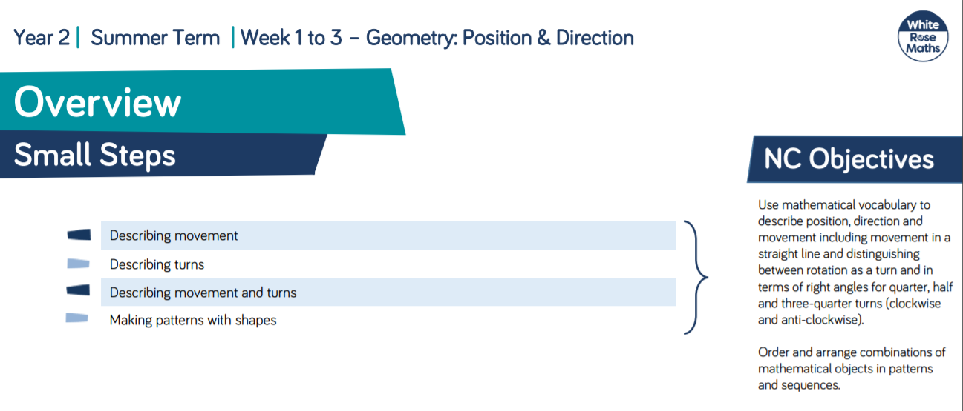

Year 2 – Summer Term – Week 4 -5 Problem solving – Problem of the Day resources /

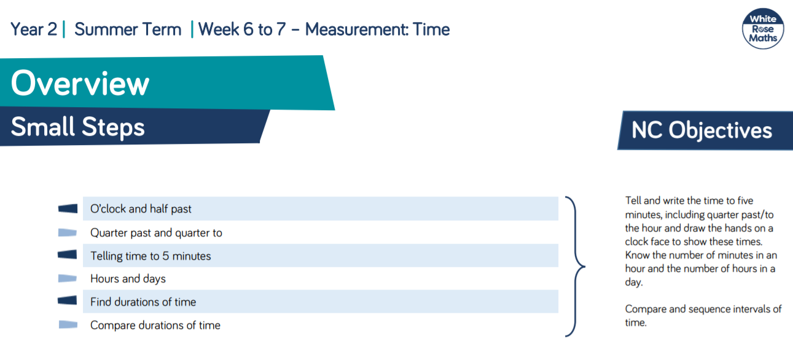

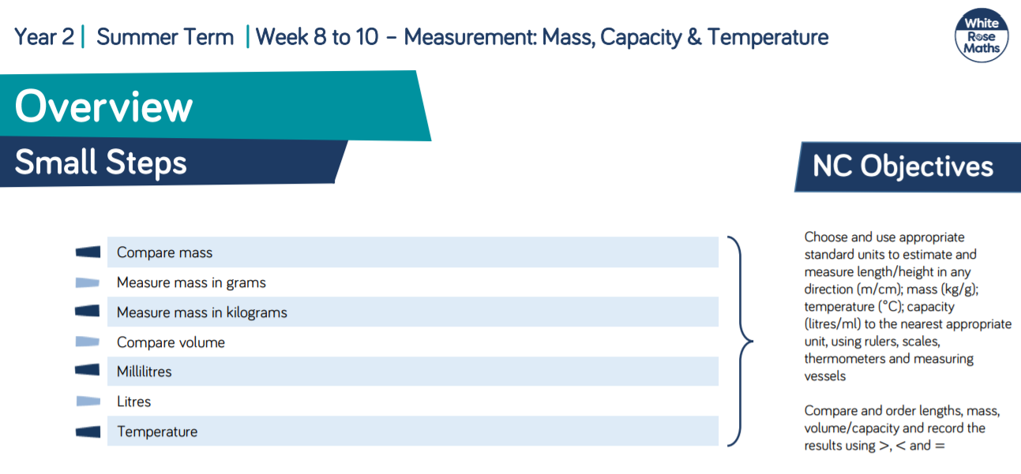

Year 2 – Summer Term Week 11 – 12: Problem solving – Problem of the Day resources.

